Bahria University,

Karachi Campus



Course: CSL 320 Operating systems Lab

Term: Spring 2022, Class: BSE- 4(B)

Submitted By:

Abdul Quddos 69984

(Name) (Reg. No.)

Submitted To:

Sir Rizwan Fazal/Engr. Rahemeen

Signed Remarks: Score:

INDEX

|  |  |  |  |  |
| --- | --- | --- | --- | --- |
| SNO | DATE | LAB NO | LAB OBJECTIVE | SIGN |
| 1 | 7 | 1 | Introduction To Linux Ubuntu |  |
| 2 | 14 | 2 | Linux Commands and Shell Scripting |  |
|  |  |  |  |  |
|  |  |  |  |  |
|  |  |  |  |  |
|  |  |  |  |  |
|  |  |  |  |  |
|  |  |  |  |  |
|  |  |  |  |  |
|  |  |  |  |  |
|  |  |  |  |  |
|  |  |  |  |  |
|  |  |  |  |  |
|  |  |  |  |  |
|  |  |  |  |  |
|  |  |  |  |  |
|  |  |  |  |  |
|  |  |  |  |  |
|  |  |  |  |  |
|  |  |  |  |  |

Bahria University,

Karachi Campus



LAB EXPERIMENT NO.

2

LIST OF TASKS

|  |  |
| --- | --- |
| TASK NO | OBJECTIVE |
| 1 | Practice all the Linux commands discussed in this lab while taking assistance using the **man** command. Write the complete syntax used for utilizing the **cp**, **mv** and **rm** commands in Linux shell. |
| 2 | Write the C programs provided in this lab and generate their outputs over Linux environment (provide snapshot). |
| 3 | Write a C program on the Linux environment that takes your marks as an input and display your grades accordingly to that followed at Bahria University. Limit your program to a maximum of five subjects. Use the suitable logical operator(s), i.e. and (&&), or (||), not (!), if required. |
| 4 | Write a shell script to display your address over multiple lines. |
| 5 | Write a shell script that would traverse among any three directories that are placed under the /home directory. While moving from one directory to another, the script should display the name of the current working directory and list the content within that directory, including the hidden files. |
|  |  |
|  |  |
|  |  |
|  |  |
|  |  |

Submitted On:

(Date: 21/3/22)

**LAB # 02**

**Task # 01:**

**Practice all the Linux commands discussed in this lab while taking assistance using the man command. Write the complete syntax used for utilizing the cp, mv and rm commands in Linux shell.**

**Solution:**

cp command:-

Syntax:- cp <source_file_name> <destination_file_name> 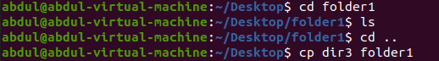 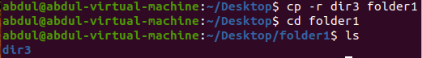

mv command:-

Syntax:- mv <source_file_name> <destination_file_name>

 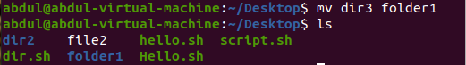

rm command:-

Syntax:- rm <file_name>

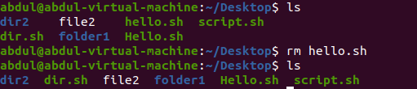

mkdir command:-

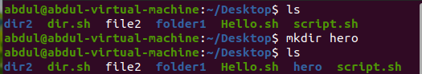

rmdir command:-

 

pwd command:-



who command:-



whoami command:-



uname command:-



groups command:-



**Output:**

**Task#2:**

**Write the C programs provided in this lab and generate their outputs over Linux environment (provide snapshot).**

**Solution:**



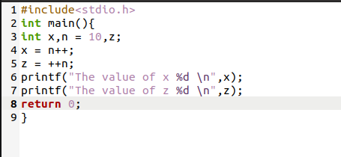 

**Output:**



**Task#2.2:**

**2nd C program**

**Solution:**

 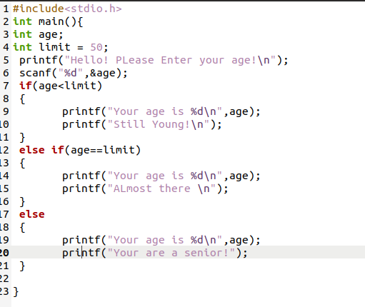 

**Output:**

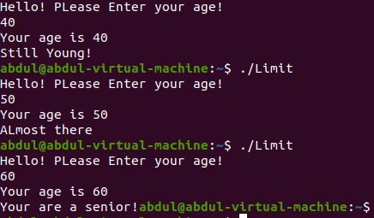

**Task#3:**

**Write a C program on the Linux environment that takes your marks as an input and display your grades accordingly to that followed at Bahria University. Limit your program to a maximum of five subjects. Use the suitable logical operator(s), i.e. and (&&), or (||), not (!), if required.**

**Solution:**

 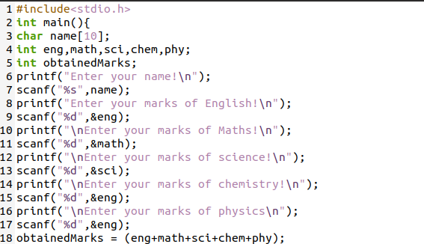 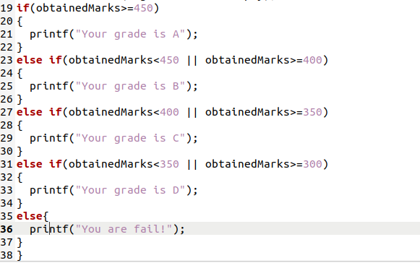 

**Output:**

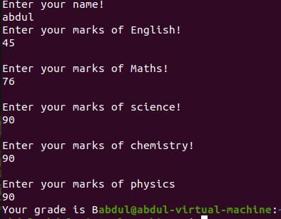

**Task#4:**

**Write a shell script to display your address over multiple lines.**

**Solution:**



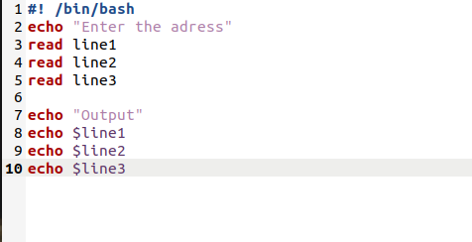

**Output:**

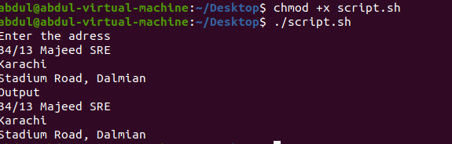

**Task#5:**

**Write a shell script that would traverse among any three directories that are placed under the /home directory. While moving from one directory to another, the script should display the name of the current working directory and list the content within that directory, including the hidden files.**

**Solution:**

